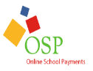

Baltimore County Parent Purchase Instructions
for School Activities
This document is the instructions for how parents can make purchases in the OSP eStore.
If you have any questions or comments, please contact the OSMS Support Desk either by emailing support@osmsinc.com or by calling 703-378-8299 ext. 204.
-The OSMS Support Desk

- Navigate to the Online School Payments website from any web browser. This web address is custom to your school district. click here to access link to OSP https://osp.osmsinc.com/baltimorecountymd/

- Select your school name from School sidebar on the left side of the page. You may need to select the Category Name (that is Elementary Schools, Middle Schools, High Schools etc.) to display the school names.
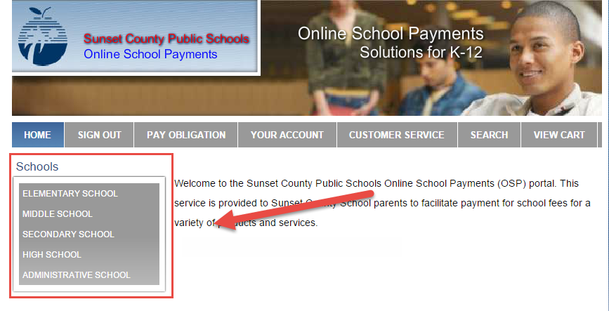
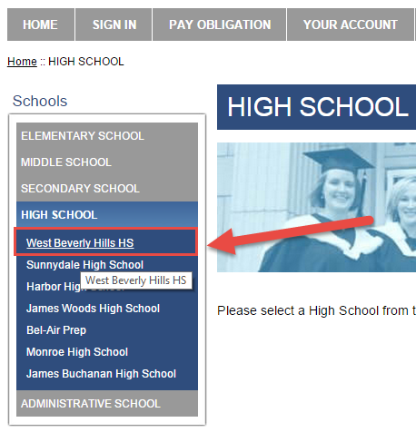
- Select any Activities (sale items) you wish to purchase by selecting the Activity Name.

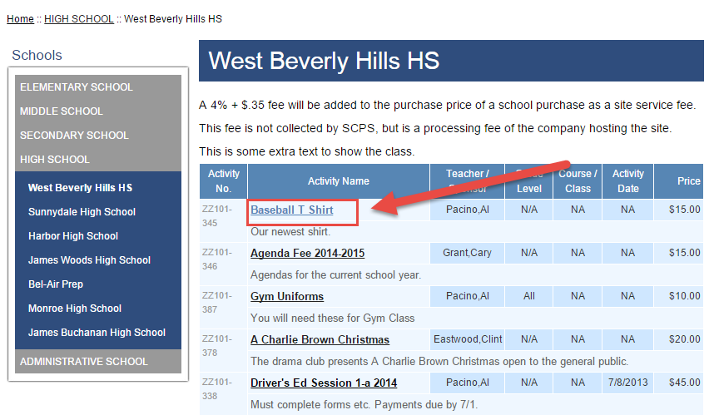

- This will take you to the Item page. Select the Add to Cart button to add this item your Shopping Cart.
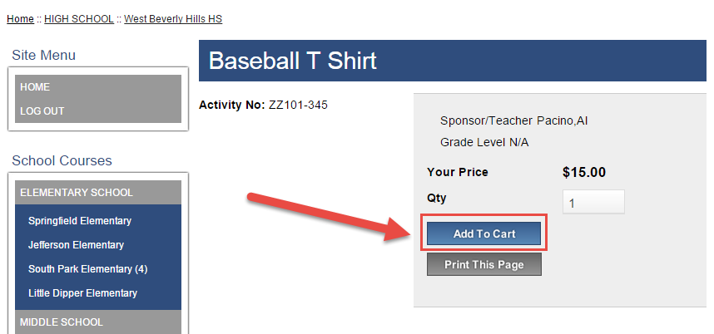

- This will take you to the Shopping Cart page. You may either select the Continue Shopping button to add more items to your Shopping Cart (return to step 3) or press the Checkout button to complete the payment.
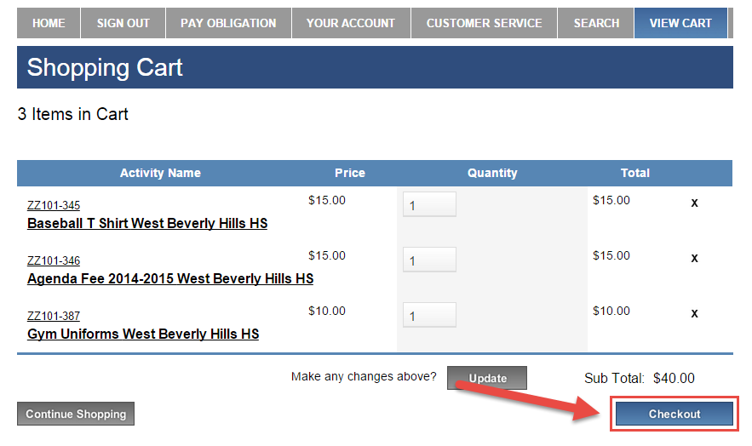
- If you are not already logged in, the system will redirect you to the Sign In page. You will now be asked to login if you’ve used the system before or to create a parent user account.
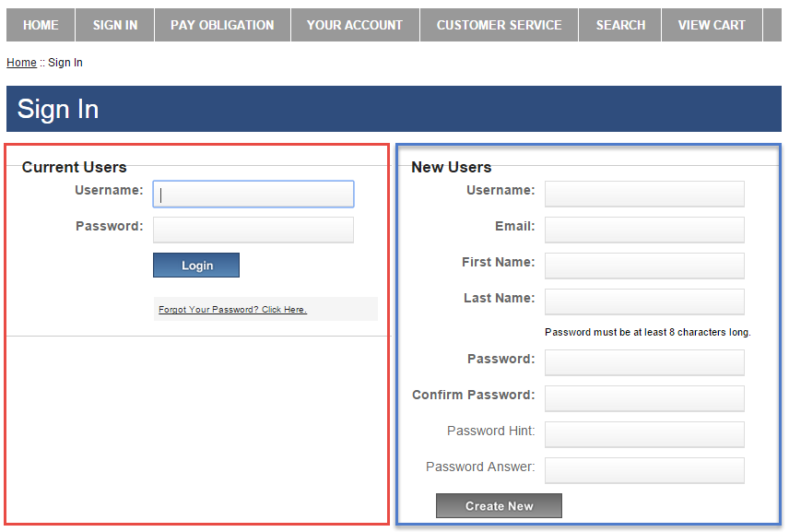
- This will then start the Check Out process. There are 4 steps, 1 step per page.

The 1st page is called Step 1 of 4 – Assign Student Profile To Activity. For each individual line item, you will need to select a Student Profile to give them credit for that item. Next to the Select Student Profile, click on the down arrow to display your student names. Highlight the name to select and give them credit. Select the Next button when complete.

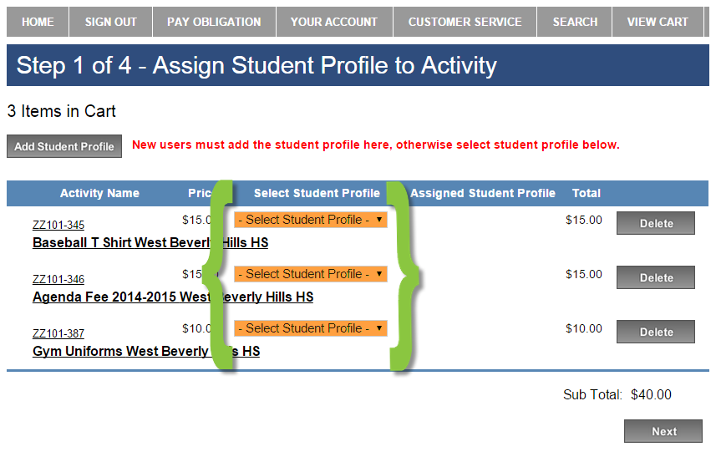

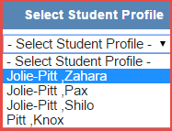

- If your list of students is empty, select the Add Student Profile button to the top left.

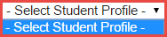

Add your student’s info, and then select the Save Changes button. Be sure to follow any instructions regarding Student ID Numbers. Now, you can assign the student profile in Step 7.

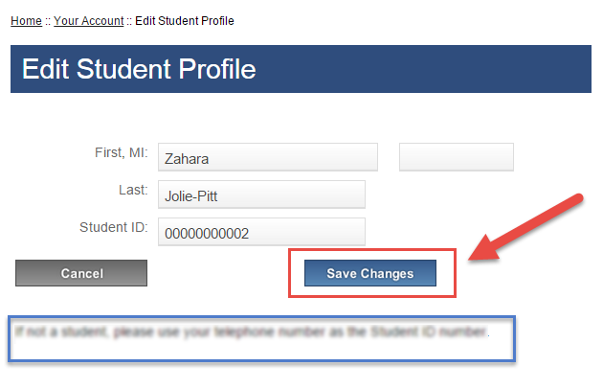

- Next, on the Step 2 of 4 – Address page, type in your billing information. If there’s any difference, be sure it’s billing not home address. Select the Next button when finished.
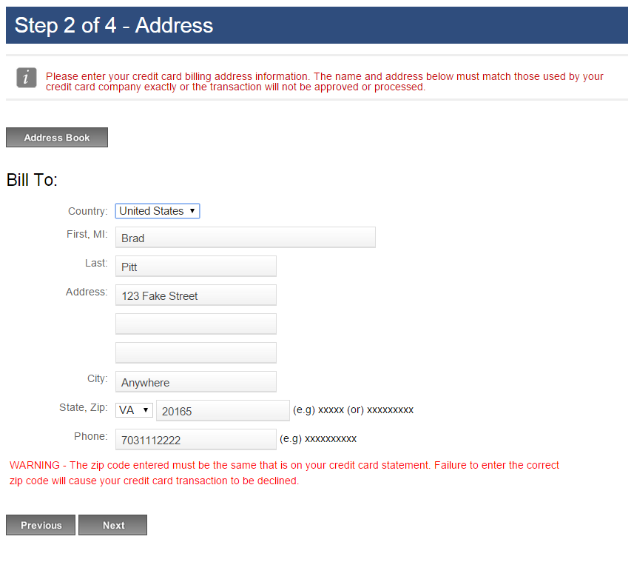
- Next, on the Step 3 of 4 – Payment page, type in your credit card info. Select the Review Order button when finished.
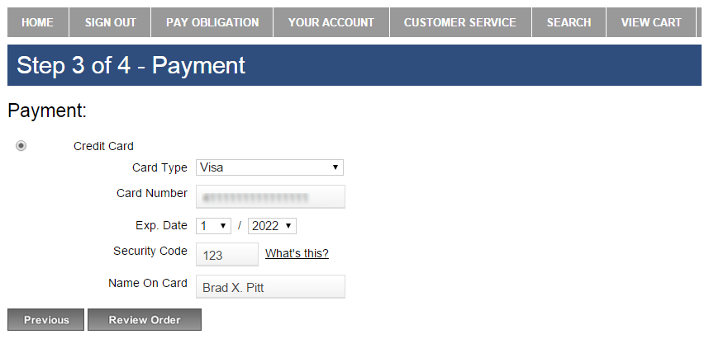

- Finally, on the Step 4 of 4 – Review Order page, please make sure the order looks correct. Select the box to agree to the Terms and Conditions, and then select the Place Order button.
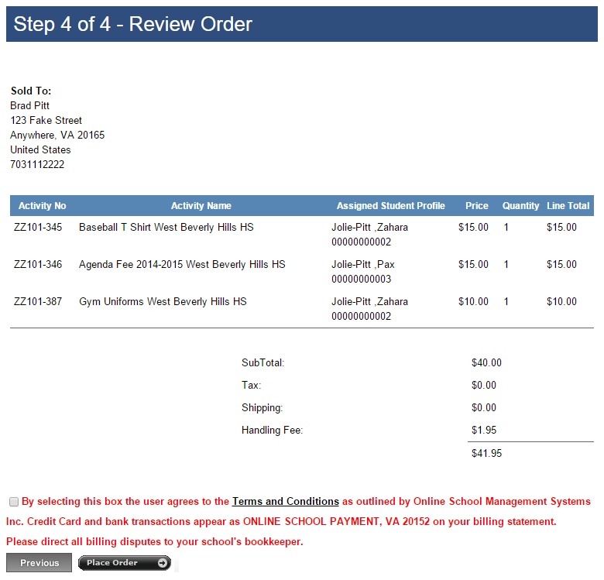

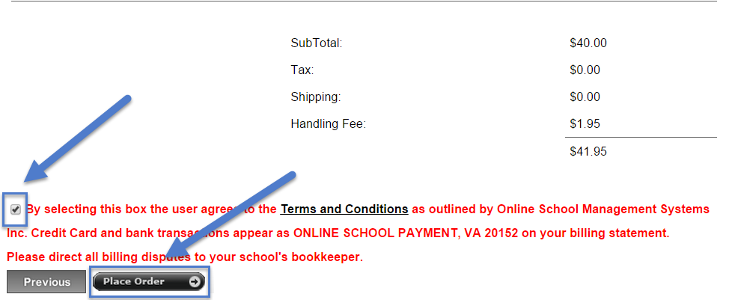

- Once the transaction is successfully completed, a Thank You message with the Order Number will display. A receipt is also sent to your email address and is always stored in your OSP account under the Your Account tab.
